**Khushal Soni SQL201 Assignment 1**

Q1. For different category of acquirers, what is the average number of months since the inception of the acquired company after which they are acquired?

ANS- SELECT

COALESCE(a.acquirer_category_code, 'missing') AS acquirer_category_code,

ROUND(avg(abs(a.acquired_at :: date - c.founded_at_clean :: date)/(365/12)), 1) AS idff

FROM tutorial.crunchbase_acquisitions_clean_date a

LEFT JOIN tutorial.crunchbase_companies_clean_date c ON a.company_permalink = c.permalink

WHERE c.founded_at_clean IS NOT NULL

GROUP BY 1

ORDER BY 1

Result-

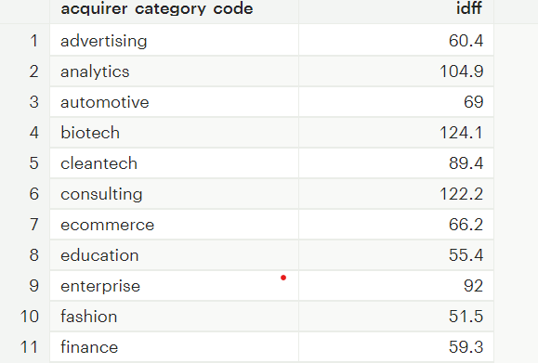

Q2. Is there any trend for quarters when more companies are acquired?

Query –

SELECT

SUM(CASE WHEN extract(month from acquired_at_cleaned) ::integer <= 3 THEN 1 ELSE 0 END) as Q1,

SUM(CASE WHEN extract(month from acquired_at_cleaned) ::integer <=6

AND extract(month from acquired_at_cleaned) ::integer >3 THEN 1 ELSE 0 END) as Q2,

SUM(CASE WHEN extract(month from acquired_at_cleaned) ::integer <=9

AND extract(month from acquired_at_cleaned) ::integer >6 THEN 1 ELSE 0 END) as Q3,

SUM(CASE WHEN extract(month from acquired_at_cleaned) ::integer <=12

AND extract(month from acquired_at_cleaned) ::integer >9 THEN 1 ELSE 0 END) as Q4

FROM tutorial.crunchbase_acquisitions_clean_date

WHERE acquired_at_cleaned is not null

Result –

Q3. For each company_category_code identify the average raised_amount_usd per quarter?

Query –

SELECT COALESCE(company_category_code,'others') as categories,

SUBSTRING(funded_quarter FROM 6 FOR 2) quarters,

ROUND(AVG(raised_amount_usd :: numeric)) AS average_raised_amount

FROM tutorial.crunchbase_investments

WHERE raised_amount_usd IS NOT NULL

GROUP BY 1,2

ORDER BY 1,2

Result-

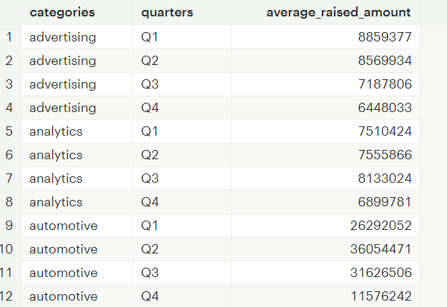

Q4. Which investor (company ) is more likely to invest in USA based companies?

Query –

select investor_name , count(*)

from tutorial.crunchbase_investments

where company_country_code = 'USA'

group by 1

order by count(*) desc

result -

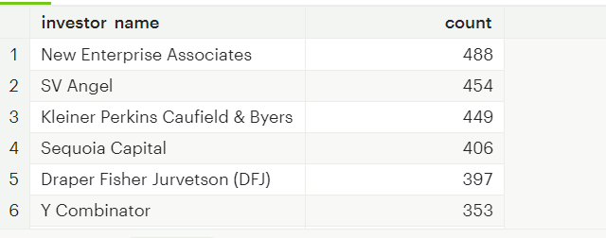

Q5. For different type of funding rounds, what is the average raised amount per quarter?

Query –

SELECT COALESCE(funding_round_type,'others') round_type ,SUBSTRING(funded_quarter FROM 6 FOR 2) quarter,

ROUND(AVG(raised_amount_usd :: numeric)) as average_raised_amount

FROM tutorial.crunchbase_investments

WHERE raised_amount_usd IS NOT NULL

GROUP BY 1,2

Result-

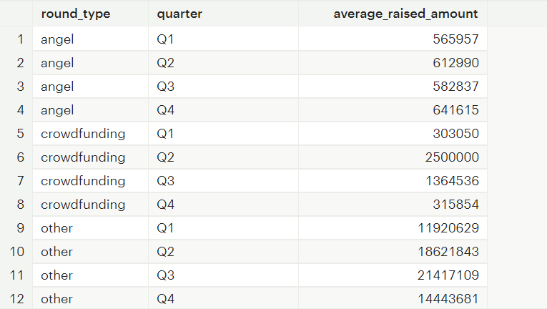

Q6. Identify companies that received an investment from Japan following an investment from Great Britain where investor is finance category company?

SELECT a.company_name

FROM (

SELECT company_name, investor_country_code,

lead(investor_country_code) OVER( order by funded_at ) AS next_investor_country

from tutorial.crunchbase_investments

here investor_category_code = 'finance') a

WHERE a.investor_country_code = 'GBR' AND a.next_investor_country = 'JPN'

Q7. Out of all 'operating' status companies, which category of companies have the highest average funding_total_usd?

Query-

SELECT category_code, AVG(funding_total_usd) ::integer as Avg_Funding

FROM tutorial.crunchbase_companies_clean_date

WHERE status='operating'

GROUP BY category_code

order by 2 desc

result-

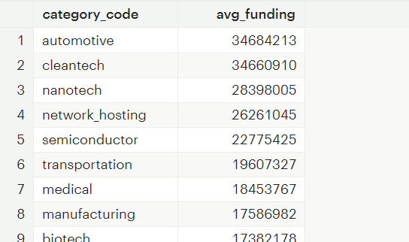

Q8. For each category, what percent of companies received funding within 3 years of their founding?

Query –

SELECT COALESCE(category_code,'others') category,

ROUND(100*SUM(CASE WHEN (first_funding_at :: date - founded_at :: date)<1095 THEN 1

ELSE 0 END)/(count(category_code)::decimal),2) as Percentage

FROM tutorial.crunchbase_companies

where category_code IS NOT NULL

AND first_funding_at IS NOT NULL

AND founded_at IS NOT NULL

GROUP BY 1

Result-

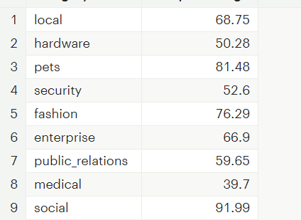

Q9. Clean the 'last_funding_at' column (convert it to time stamp) and get the time difference with the current time.

SELECT *, last_funding_at :: date as last_funding_at_cleaned ,

(now() - last_funding_at :: date) AS time_difference

FROM tutorial.crunchbase_companies

